Prelegent:
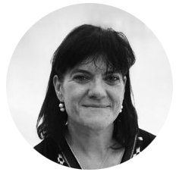

Dr Carmen Lorente-Méndez DVM, PhD, Dipl. ECVD

1988
DVM, Univ. Complutense de Madrid
1989
Founder and Director of Clínica Veterinaria Cercedilla
2000
Head of Dermatology of Univ. CEU Cardenal Herrera
2000
Prof. Univ. CEU Cardenal Herrera
2005
PhD, Univ. Complutense de Madrid
2007
Founder and Director of ADERVET
2008
Head of Dermatology and Internal Medicine, Univ. Alfonso X El Sabio
2011
Dipl.ECVD
2016
Dermatopathologist at Diavet
2018
LABOKLIN – Dermatology and Allergy

